**Exercises**

1. Reduce the number of training examples by half. Compare training time, predictions, and loss. **Bibiana**

| **Number of training examples** | **total loss** | **cls loss** | **box loss** | **mask loss** | **rpn cls loss** | **rpn loc loss** | **Training Time** |
| --- | --- | --- | --- | --- | --- | --- | --- |
| Total | 0.3423 | 0.06097 | 0.1493 | 0.07693 | 0.008851 | 0.005324 | 0:02:29 |
| half | 0.2725 | 0.05967 | 0.1327 | 0.07329 | 0.008354 | 0.004611 | 0:02:33 |





1. Increase the learning rate and analyze the results. **Emanuel**

| **learning rate** | **total loss** | **cls loss** | **box loss** | **mask loss** | **rpn cls loss** | **rpn loc loss** |
| --- | --- | --- | --- | --- | --- | --- |
| 0.00025 | 0.3551 | 0.0694 | 0.1404 | 0.0824 | 0.0076 | 0.0070 |
| 0.00075 | 0.2530 | 0.0440 | 0.1358 | 0.0608 | 0.0014 | 0.0054 |
| 0.001 | 0.2761 | 0.0492 | 0.1314 | 0.0666 | 0.0022 | 0.0050 |
| 0.01 | 0.3502 | 0.0530 | 0.2121 | 0.0510 | 0.0015 | 0.0098 |
| 0.1 | - | - | - | - | - | - |

**Significant fluctuations begin to appear at a lr = 0.001.**

**lr 0.00025 prediction:**



**lr 0.00075 prediction:**



**lr 0.001 prediction:**



**lr 0.01 prediction:**



**lr 0.1:**

**Discussion:**

When testing different learning rates on the balloons dataset with Detectron2, the results showed that smaller values like 0.00025 and 0.00075 led to smooth and stable decreases in the loss, with 0.00075 performing the best overall. At 0.001, the training still worked but the losses fluctuated much more between iterations, showing less stability. With a higher rate of 0.01, the box loss grew noticeably, and training became unstable, while at 0.1 the model completely diverged, producing Inf/NaN values. In short, this experiment confirms that very low learning rates are safe but slower, very high ones break training, and the sweet spot for this dataset was around 0.00075, where the balance between speed and stability was the best.

Additional proof:

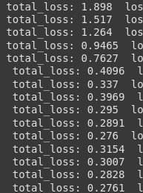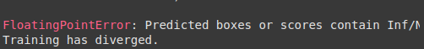

1. Increase the maximum number of iterations and note the impact. **Emanuel**

Training uses learning rate of 0.00075

| **max iterations** | **total loss** | **cls loss** | **box loss** | **mask loss** | **rpn cls loss** | **rpn loc loss** |
| --- | --- | --- | --- | --- | --- | --- |
| 300 | 0.2530 | 0.0440 | 0.1358 | 0.0608 | 0.0014 | 0.0054 |
| 400 | 0.2533 | 0.0452 | 0.1287 | 0.0546 | 0.0030 | 0.0054 |
| 500 | 0.2413 | 0.0503 | 0.1099 | 0.0548 | 0.0014 | 0.0038 |
| 600 | 0.3056 | 0.0518 | 0.1530 | 0.0654 | 0.0030 | 0.0059 |

Mencionar que hay fluctuación pero suele bajar el loss, entonces es buena idea implementar un call back

**300 iter preds:**

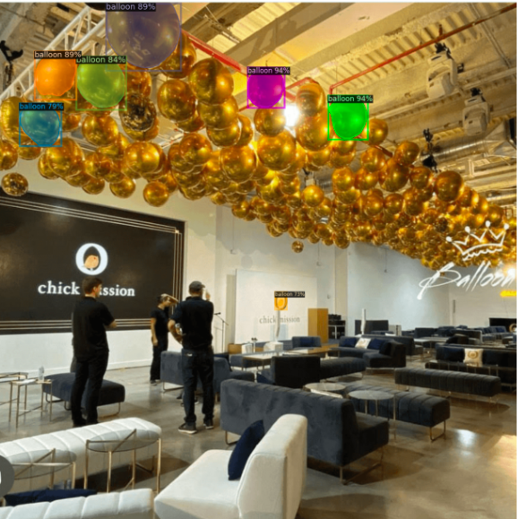

**400 iter preds:**



**500 iter preds:**



**600 iter preds:**



**Discussion**Using a learning rate of 0.00075, we tested different values of maximum iterations, and the results showed that increasing the iterations generally helped to reduce the losses further, especially the box and mask losses, with the best results appearing around 500 iterations. However, we also observed that as iterations increased, the training curves became more fluctuating, although still controlled compared to higher learning rates. Interestingly, at 600 iterations the total loss increased again, suggesting that going too far may start to hurt instead of improve. Based on this, a good practice would be to add callbacks such as early stopping, so that training automatically stops when the model stops improving. Overall, looking at the predictions on the test images, more iterations seem to bring better results, but it is safer to let callbacks decide when to stop rather than fixing a maximum number in advance.

1. Modify the test threshold to make a better prediction **Alejandro**

**Threshold 0.7 (Default)**



**Threshold 0.6**



**More balloons detected without introducing false positives**

**Threshold 0.4**



**Threshold 0.2**



**Threshold 0.95**



**Conclusion**

When adjusting the detection threshold of the model, the results show the expected performance. At low thresholds the model identifies many more balloons, but with a lot of false positives and some duplicate boxes, but at higher thresholds the predictions become more reliable but it misses a large number of balloons. However, even at the lowest threshold tested (0.2) the model was not able to detect a huge amount of balloons from the test image, indicating that it still requires further fine-tuning or additional training data to perform better in crowded scenes.

1. Test with your own image and summarize your observations. **Alejandro**

**Test image**

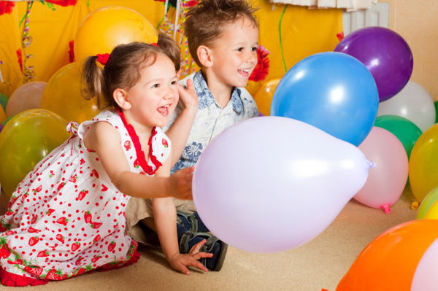

For this test, the model was configured with the best parameters obtained from previous exercises in terms of learning rate, max iterations and threshold. Fine-tuning process with half and full dataset will be compared.

**Model**

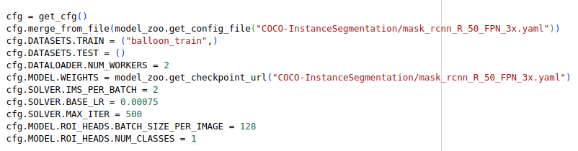

Threshold 0.6

**Full dataset**

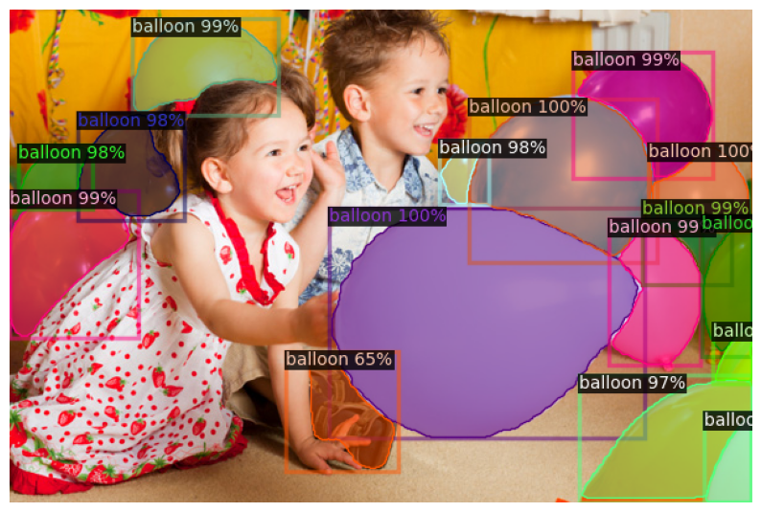

**Half dataset**

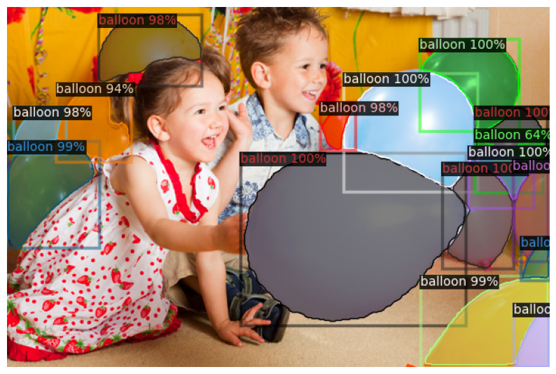

When comparing the models trained on the full and half datasets on this unseen image, the results align with the metrics from the first exercise. The model trained with half of the dataset produced a better detection, while the full-dataset model introduced a false positive by detecting a balloon that was not present. This outcome shows that increasing the dataset size does not automatically guarantee better performance, as it may also introduce noise, redundancy, or imbalance.